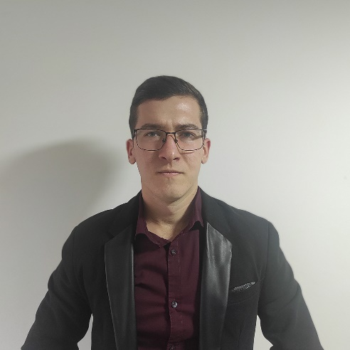

**High School**

May 2017

Economic Tehnician

* HTML5
* CSS
* Photoshop
* Adobe Illustrator
* Canva
* Microsoft Office

My Porfolio

[My Github](https://github.com/ColaWizard)

+381606031234

aleksandarsubotic300@gmail.com

Serbia - Vladimirci

***LANGUAGES***

* ***SERBIAN***
* ***ENGLISH***

***HOBBIES***

* ***READING***
* ***SPORTS***
* ***TRAVELING***

***SKILLS***

Worked in a car service company for five years, where I took part in:

* Marketing
* Financial Management
* Customer Service
* Equipment Investments

***EXPERIENCE***

***EDUCATION***

Seeking a good job where I can learn and grow, also to bring value to the given company. To get an opportunity where I can make the best of my potential and contribute to the organization’s growth.

***OBJECTIVE***

***Aleksandar***

***Subotic***